Technical Information

Technical Contacts: Tamlin Wiltshire, Production Manager (touring)
+44 (0)7812 558 715 (mobile)
tamlinwiltshire@hotmail.com

Company on tour: Shona Reppe - Performer
Tamlin Wiltshire - Production Manager
Please note that Shona and Tamlin will on most occasions tour with their two children and a child minder who will require back stage access. Details will be given in advance

Vehicles: Car with Trailer
Parking will be required. Please advise the Production Manager in advance if this is not possible

Freight: For international touring, the set will travel in one timber, wheeled crate.
Dimensions: 185cms(l) x 61cms(d) x 89cms(h)
Weight: 168kgs

Arrival time at venue: with lighting - minimum 4 hours before performance
Without lighting – minimum 2 hours before performance
Get out: 1.5 hours
Running time: 35 minutes (no interval)

Venue Requirements Potato Needs a Bath is an intimate show for 3 to 5 years and their families. It is performed in end on format for a maximum audience of between 40 and 60 depending on the venue size and seating arrangements.

Potato Needs a Bath is best performed in small theatre spaces with the audience and set on the same level. Raked seating will not be required and the audience cannot be separated by a raised stage.

The audience will be mainly seated on the floor with a row of chairs at the back and a row of benches. Cushions will be provided by the company for UK touring only. Venues should supply 15 comfortable chairs, benches and mats. International venues must supply chairs, benches, mats and cushions

A performance area of 4meters x 4meters with at least 3meters height clearance is required. The performance area must be level with the audience.
Black backdrop is required. Black floor is preferred.
The venue should have basic lighting and sound facilities. In the UK, the company can tour technical equipment, however additional get in and out time will be required
The venue should be able to achieve blackout although this is not essential.

Set Details Blue dance floor 3meters x 3meters. This will be taped to the venue floor
Low yellow skirt at rear
Various pieces of small furniture

One 12inch helium balloon is used during the performance. The company will supply helium for UK touring only. International venues must supply enough helium for the duration of their run.

Sound Requirements 2 speakers situated on floor level at the back of the set (minimum 300w each)
Playback from apple mac laptop computer running Qlab software with audio interface

For UK touring, all equipment can be provided by the company on tour although we prefer the venue to supply the main two speakers and amplification.

For international touring, the venue must provide all equipment with the exception of Laptop computer and audio interface. Equipment required:
- Mixing desk with 2 available input channels and 2 output channels
- Speakers and amplification
- Cabling from control desk to speakers

Lighting Basic lighting design (see attached plan)
- a programmable lighting desk
- 12 circuits of dimming (including 1 cannel for house lights)
- 8 fresnels with barn doors, 7 narrow profiles (3 with Iris’s)
- Audience lighting
- Rotating mirror ball that can either be put through a dimmer or have a switchable power supply
240v 5amp power supplies are required at the control position and behind the set

Operation: Both lighting and sound will be operated by the touring Production manager
Lighting and Sound must be situated together to allow for operation by one person.

Effects no special effects

Risk Assessment The performance has no identifiable risks

Front of House information The audience will be held outside the performance space until the house opens at the advertised start time. The performance will begin as soon as the audience are in the space and settled.
Latecomers can be admitted although if it is clear that a large proportion of the audience are missing before the house opens, it would be the preference of the company to hold the show.
Front of house staff must be in the venue to monitor the audience for the duration of the performance.

PRS information All recorded music is from an original score by Dave Trouton

Dressing Rooms 1 Dressing room required with full length mirror

Laundry Access to laundry facilities is required at venues programming two or more shows.

The Set

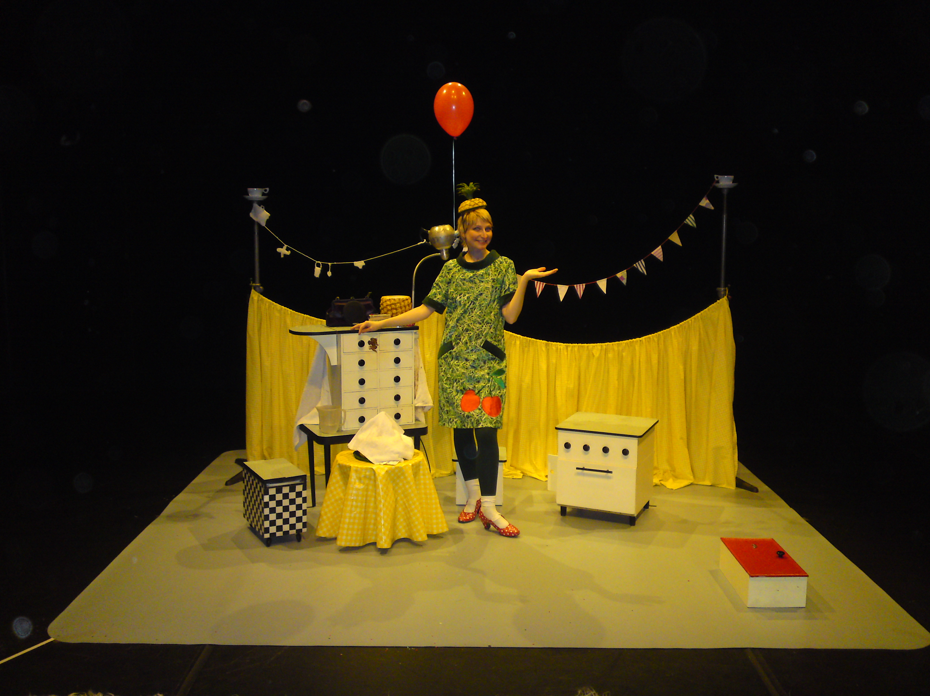

Lighting Plan
(not to scale)


